**Please Find the Earth Quake Census Details :**

Here’s the raw file of the EarthQuake Census details .



Please find the Map-Reduce Details :

Attaching the Jar File.



This Jar File is Created as Maven Install. PFB the pom.xml file.



**Few Details of the pom.xml file Is shown below :**

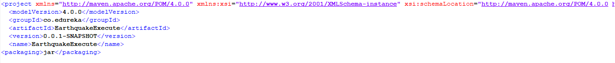

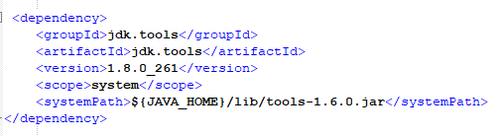

**Here’s the command execution details using hadoop jar.**

hadoop jar EarthquakeExecute-0.0.1-SNAPSHOT.jar /user/edureka_918210/Earthq/Earthquake.txt EarthQuake_09_24_2020

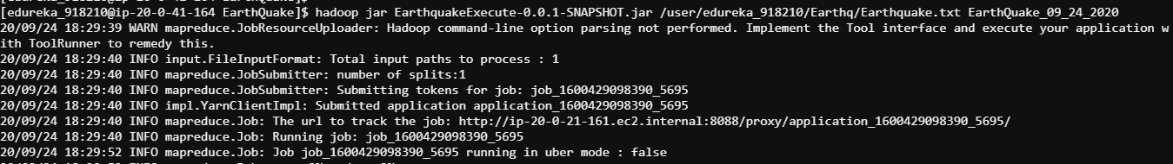

History Server : MapReduce Job

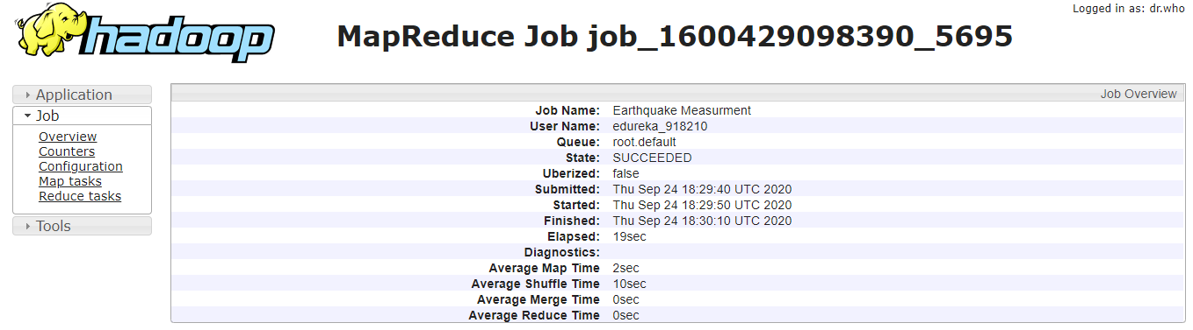

**Please find the sample output details :**

Here is the Sample Output Details :



